Plotting Position
Purpose
How to interpret position data as, visual, numerical, graphical and symbolic.
Curriculum Outcome(s):
S2-3-01 Analyze the relationship among displacement, time, and velocity for an object in uniform motion.
Include: visual, numeric, graphical, symbolic (velocity = Δd/Δt).

Part A – Visual
Using the data page, answer the following questions
- Do all objects start at the same point? _____________________
  - If any, which object(s) have a “head start”? ______________________________
- Which object(s) traveled for the longest period of time? __________________________
- Which objects would have the same origin? ____________________________________
- Which object has traveled the farthest?_________________
- Which object(s) is traveling the fastest? ____________________
  - How can you tell? _________________________________________________________
- Which object(s) is traveling the slowest? ___________________
  - How can you tell? _________________________________________________________
- Draw a series of positions that would use 4 seconds of time in total, at 0.5 second intervals and reaches a final position of 18cm from an origin.

Part B – Numerical
For each object, measure the position of each dot, relative to the origin (the bottom dot is the origin for each object). Make sure the zero of your ruler stays on the origin for each measurement.
Object U |  |  | Object V |  |  | Object W
Time (s) | Position (cm) |  | Time (s) | Position (cm) |  | Time (s) | Position (cm)
0.0 | 0.00
0.5
1.0
1.5
2.0
2.5
3.0
3.5
4.0
4.5
5.0
Object X |  |  | Object Y |  |  | Object Z
Time (s) | Position (cm) |  | Time (s) | Position (cm) |  | Time (s) | Position (cm)
Using the tables above, answer the following questions
- Why is it important to measure on the same location of the dot each time? _____________________________________________________________________________
- Why must you always measure each position from the origin? _____________________________________________________________________________
- How do values support your findings from Part A? ______________________________________________________________________________
Part C – Graphical
Using the tables of Part B, create a graph for each object of position vs. time
- Place time on the x-axis
- Place Position on the y-axis
- All 6 graphs need to use the same x & y-axis
  - All need to use the same number scales for time and position
  - Helpful to use different colours and/or solid and dotted lines
- Draw a line for each graph (connect the dots)
- Include the appropriate labels in all locations

Use the graphs you created to answer the following questions
- Are the lines straight, or curved? ___________________________________________________
- What does a straight line mean? ___________________________________________________
- What would a flat, straight line mean? ______________________________________________
- How can you tell which object is traveling the fastest? __________________________________ ______________________________________________________________________________
- Which line(s) are the steepest? ____________________________________________________
  - How could you determine a value to the steepness of the line?
    - (For example, you may think that line W is 2 times as steep as line Z. How could you use numbers to prove/disprove this?)
________________________________________________________________________________________________________________________________________________________________________________________________________________________________________________________________________________________________
- For each graph, is there anything that is remaining constant? If yes, what is it? ____________________________________________________________________________________________________________________________________________________________
Data
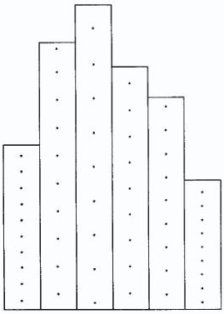
Each “strip” represents dots left behind by a moving object. The dots occur at regular time intervals of 0.5 seconds.
Objects:
W
U
V
X
Y
Z
Origin

